**Spring REST Hands-on:**

**1)Create a Spring Web Project using Maven**

**SpringLearnApplication.java**

package com.cognizant;

import org.springframework.boot.SpringApplication;

import org.springframework.boot.autoconfigure.SpringBootApplication;

@SpringBootApplication

public class SpringLearnApplication {

public static void main(String[] args) {

SpringApplication.run(SpringLearnApplication.class, args);

System.out.println("Spring Boot Application Started!");

}

}

**Output:**

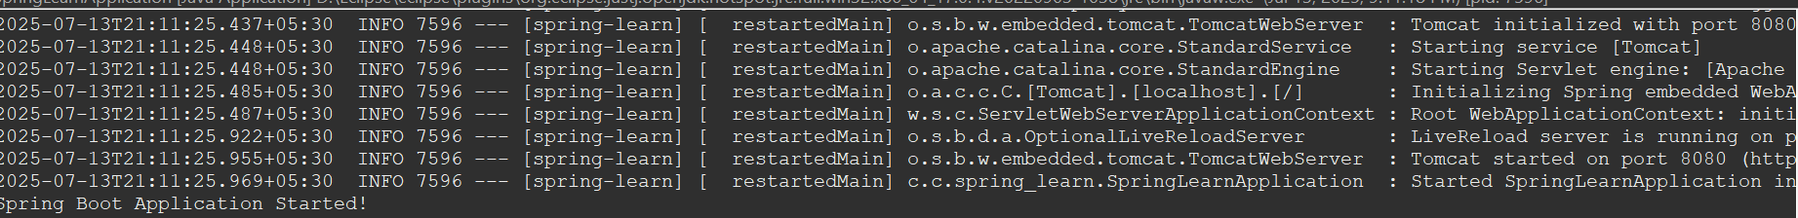

**2)Spring Core – Load Country from Spring Configuration XML   
SpringLearnApplication.java**

package com.cognizant.spring_learn;

import org.slf4j.Logger;

import org.slf4j.LoggerFactory;

import org.springframework.context.ApplicationContext;

import org.springframework.context.support.ClassPathXmlApplicationContext;

import com.cognizant.spring_learn.Country;

public class SpringLearnApplication {

private static final Logger *LOGGER* = LoggerFactory.*getLogger*(SpringLearnApplication.class);

public static void main(String[] args) {

*LOGGER*.info("START");

*displayCountry*();

*LOGGER*.info("END");

}

public static void displayCountry() {

ApplicationContext context = new ClassPathXmlApplicationContext("country.xml");

Country country = (Country) context.getBean("country", Country.class);

*LOGGER*.debug("Country : {}", country.toString());

}

}

**Country.java**

package com.cognizant.spring_learn;

import org.slf4j.Logger;

import org.slf4j.LoggerFactory;

public class Country {

private static final Logger LOGGER = LoggerFactory.getLogger(Country.class);

private String code;

private String name;

public Country() {

System.out.println("Inside Country Constructor");

LOGGER.debug("Inside Country Constructor.");

}

public String getCode() {

LOGGER.debug("Inside getCode");

return code;

}

public void setCode(String code) {

LOGGER.debug("Inside setCode");

this.code = code;

}

public String getName() {

LOGGER.debug("Inside getName");

return name;

}

public void setName(String name) {

LOGGER.debug("Inside setName");

this.name = name;

}

@Override

public String toString() {

return "Country [code=" + code + ", name=" + name + "]";

}

}

**country.xml**

<?xml version="1.0" encoding="UTF-8"?>

<beans xmlns="http://www.springframework.org/schema/beans"

xmlns:xsi="http://www.w3.org/2001/XMLSchema-instance"

xsi:schemaLocation="

http://www.springframework.org/schema/beans

http://www.springframework.org/schema/beans/spring-beans.xsd">

<bean id="country" class="com.cognizant.spring_learn.Country">

<property name="code" value="IN" />

<property name="name" value="India" />

</bean>

</beans>

**Output:**

21:50:02.458 [main] DEBUG com.cognizant.spring_learn.SpringLearnApplication - Country : Country [code=IN, name=India]

**3)Hello World RESTful Web Service**

**SpringLearnApplication.java**

package com.cognizant.spring_learn;

import org.springframework.boot.SpringApplication;

import org.springframework.boot.autoconfigure.SpringBootApplication;

*@SpringBootApplication*

public class SpringLearnApplication {

public static void main(String[] args) {

SpringApplication.*run*(SpringLearnApplication.class, args);

}

}

**HelloController.java**

package com.cognizant.spring_learn.controller;

import org.slf4j.Logger;

import org.slf4j.LoggerFactory;

import org.springframework.web.bind.annotation.GetMapping;

import org.springframework.web.bind.annotation.RestController;

*@RestController*

public class HelloController {

private static final Logger ***LOGGER*** = LoggerFactory.*getLogger*(HelloController.class);

*@GetMapping*("/hello")

public String sayHello() {

***LOGGER***.info("START");

String message = "Hello World!!";

***LOGGER***.info("END");

return message;

}

}

**Output:**

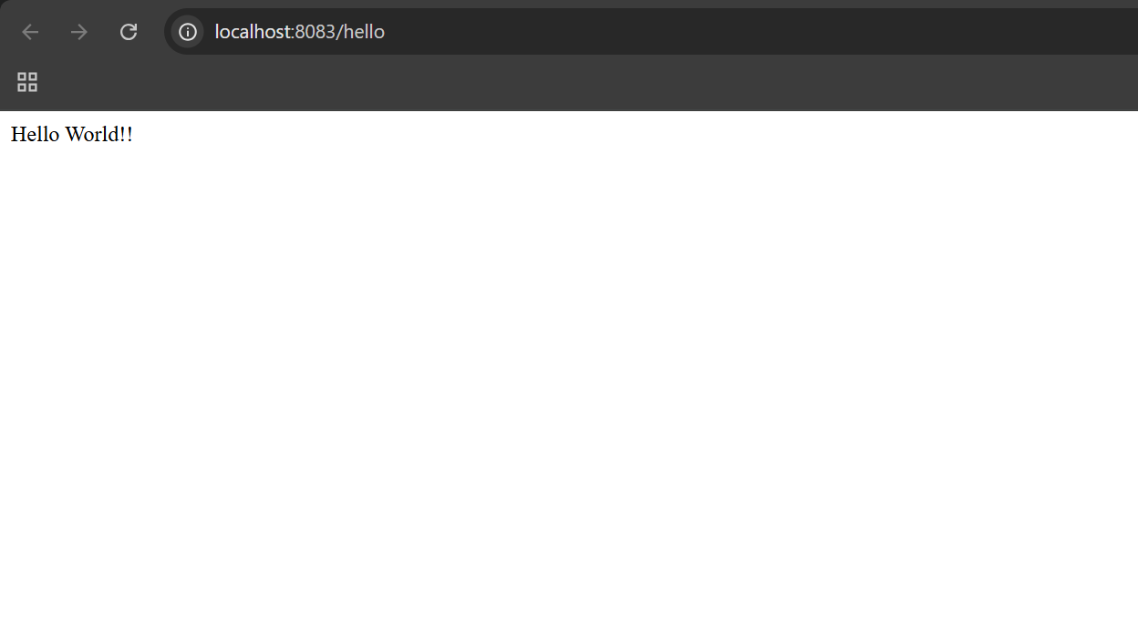

**4)REST - Country Web Service**   
**CountryController.java**

package com.cognizant.spring_learn.controller;

import com.cognizant.spring_learn.Country;

import org.slf4j.Logger;

import org.slf4j.LoggerFactory;

import org.springframework.context.ApplicationContext;

import org.springframework.context.support.ClassPathXmlApplicationContext;

import org.springframework.web.bind.annotation.RequestMapping;

import org.springframework.web.bind.annotation.RestController;

@RestController

public class CountryController {

private static final Logger LOGGER = LoggerFactory.getLogger(CountryController.class);

@RequestMapping("/country")

public Country getCountryIndia() {

LOGGER.info("START");

ApplicationContext context = new ClassPathXmlApplicationContext("country.xml");

Country country = context.getBean("country", Country.class);

LOGGER.debug("Country Bean: {}", country.toString());

LOGGER.info("END");

return country;

}

}

**Output:**

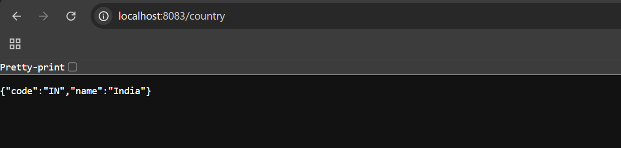

**5)REST - Get country based on country code**   
**country.xml**

<?xml version="1.0" encoding="UTF-8"?>

<beans xmlns="http://www.springframework.org/schema/beans"

xmlns:xsi="http://www.w3.org/2001/XMLSchema-instance"

xmlns:util="http://www.springframework.org/schema/util"

xsi:schemaLocation="

http://www.springframework.org/schema/beans

http://www.springframework.org/schema/beans/spring-beans.xsd

http://www.springframework.org/schema/util

http://www.springframework.org/schema/util/spring-util.xsd">

<bean id="country" class="com.cognizant.spring_learn.Country">

<property name="code" value="IN" />

<property name="name" value="India" />

</bean>

<util:list id="countryList" value-type="com.cognizant.spring_learn.Country">

<bean class="com.cognizant.spring_learn.Country">

<property name="code" value="IN" />

<property name="name" value="India" />

</bean>

<bean class="com.cognizant.spring_learn.Country">

<property name="code" value="US" />

<property name="name" value="United States" />

</bean>

<bean class="com.cognizant.spring_learn.Country">

<property name="code" value="DE" />

<property name="name" value="Germany" />

</bean>

<bean class="com.cognizant.spring_learn.Country">

<property name="code" value="JP" />

<property name="name" value="Japan" />

</bean>

</util:list>

</beans>

**CountryService.java**

package com.cognizant.spring_learn.service;

import java.util.List;

import com.cognizant.spring_learn.Country;

import org.springframework.context.ApplicationContext;

import org.springframework.context.support.ClassPathXmlApplicationContext;

import org.springframework.stereotype.Service;

@Service

public class CountryService {

public Country getCountry(String code) {

ApplicationContext context = new ClassPathXmlApplicationContext("country.xml");

List<Country> countryList = (List<Country>) context.getBean("countryList");

return countryList.stream()

.filter(c -> c.getCode().equalsIgnoreCase(code))

.findFirst()

.orElse(null); // or throw an exception if preferred

}

}

**CountryController.java**

package com.cognizant.spring_learn.controller;

import com.cognizant.spring_learn.Country;

import com.cognizant.spring_learn.service.CountryService;

import org.slf4j.Logger;

import org.slf4j.LoggerFactory;

import org.springframework.beans.factory.annotation.Autowired;

import org.springframework.web.bind.annotation.*;

@RestController

public class CountryController {

private static final Logger LOGGER = LoggerFactory.getLogger(CountryController.class);

@Autowired

private CountryService countryService;

@GetMapping("/country/{code}")

public Country getCountry(@PathVariable String code) {

LOGGER.info("START - Fetching country with code: {}", code);

Country country = countryService.getCountry(code);

LOGGER.info("END");

return country;

}

}

**Output:**

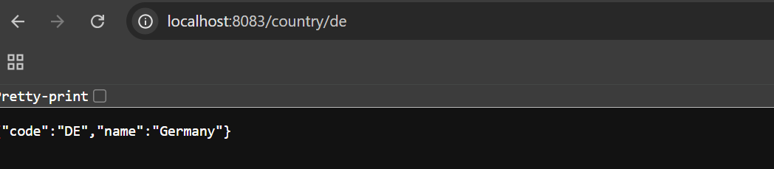

**JWT-handson**

**1)Create authentication service that returns JWT**

**JwtUtil.java**

package com.cognizant.spring_learn.util;

import io.jsonwebtoken.Jwts;

import io.jsonwebtoken.SignatureAlgorithm;

import java.util.Date;

import org.springframework.stereotype.Component;

@Component

public class JwtUtil {

private final String secretKey = "secret"; // Use strong key in real projects

public String generateToken(String username) {

return Jwts.builder()

.setSubject(username)

.setIssuedAt(new Date(System.currentTimeMillis()))

.setExpiration(new Date(System.currentTimeMillis() + 10 * 60 * 1000)) // 10 mins

.signWith(SignatureAlgorithm.HS256, secretKey)

.compact();

}

}

**AuthenticationController.java**

package com.cognizant.spring_learn.controller;

import com.cognizant.spring_learn.util.JwtUtil;

import org.springframework.beans.factory.annotation.Autowired;

import org.springframework.http.ResponseEntity;

import org.springframework.util.Base64Utils;

import org.springframework.web.bind.annotation.*;

import javax.servlet.http.HttpServletRequest;

@RestController

public class AuthenticationController {

@Autowired

private JwtUtil jwtUtil;

@RequestMapping("/authenticate")

public ResponseEntity<?> authenticate(HttpServletRequest request) {

String authHeader = request.getHeader("Authorization");

if (authHeader != null && authHeader.startsWith("Basic ")) {

String base64Credentials = authHeader.substring("Basic ".length());

String credentials = new String(Base64Utils.decodeFromString(base64Credentials));

String[] values = credentials.split(":", 2);

String username = values[0];

String password = values[1];

// Hardcoded for demo: accept user:pwd

if ("user".equals(username) && "pwd".equals(password)) {

String token = jwtUtil.generateToken(username);

return ResponseEntity.ok("{\"token\":\"" + token + "\"}");

}

}

return ResponseEntity.status(401).body("Unauthorized");

}

}

**SecurityConfig.java**

package com.cognizant.spring_learn.config;

import org.springframework.context.annotation.Configuration;

import org.springframework.security.config.annotation.web.builders.HttpSecurity;

import org.springframework.security.config.annotation.web.configuration.*;

@Configuration

@EnableWebSecurity

public class SecurityConfig extends WebSecurityConfigurerAdapter {

@Override

protected void configure(HttpSecurity http) throws Exception {

http.csrf().disable()

.authorizeRequests()

.antMatchers("/authenticate").permitAll()

.anyRequest().authenticated();

}

}

**Output:**

